TIGER CUBS ARE BACK
Richmond Harriers Athletics Club, a Fair Play Club , invites young runners aged 8 – 14 years for athletic training each Monday from 4.00 to 4.40 pm at Citizens Park Gleadell Street Richmond.
The coaching team from Richmond Harriers will conduct weekly running sessions designed to help children enhance their running abilities and general fitness. The sessions have a focus on fun inclusive
activities to improve running technique, speed and endurance for all participants.

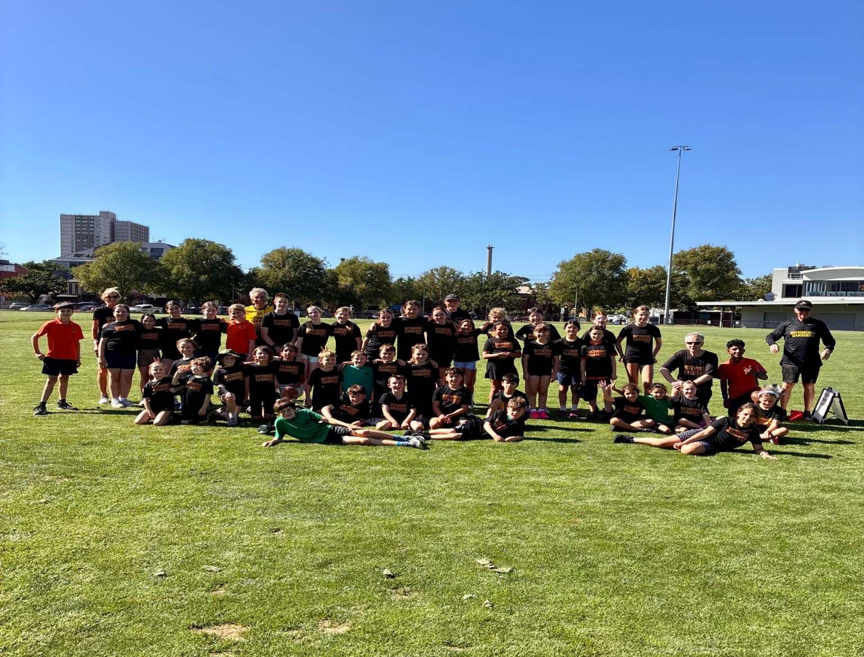
When:
Every Monday starting on 24th August through to 14th December 2026 and then from February 1st through to March 1st 2027.
To obtain a registration form please email Ron Brown on ron.brown1@optusnet.com.au or alternatively on our Richmond Harriers Website at //www.richmondharriers.org.au
Cost is $25 per child for the entire season.
For Further Information Contact Ron Brown at ron.brown1@optusnet.com.au or mobile 0419 440923

